Phase 1: Creating a python webapplication using django with command prompt

1. create a folder where we want to create the projects
2. open command prompt and navigate to the above folder
3. type the commmand to install virtual environment wrapper
pip install virtualenvwrapper-win
4. we have to create a virtual environment to create python project use the following commmand
mkvirtualenv kitsprojects
5. install django in the current virtual environment
pip install django
6. create the python webapplication using django
django-admin startproject kitsproject
7. navigate to the project folder
cd kitsproject
8. create an app under the project folder
python manage.py startapp kitsapp
9. run the server and see the default page launched for the created new python web application
python manage.py runserver
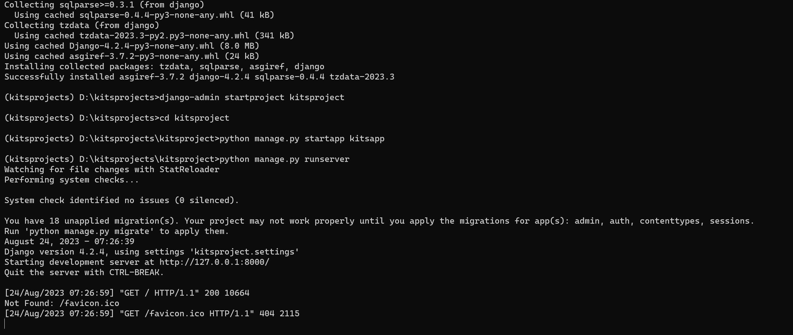
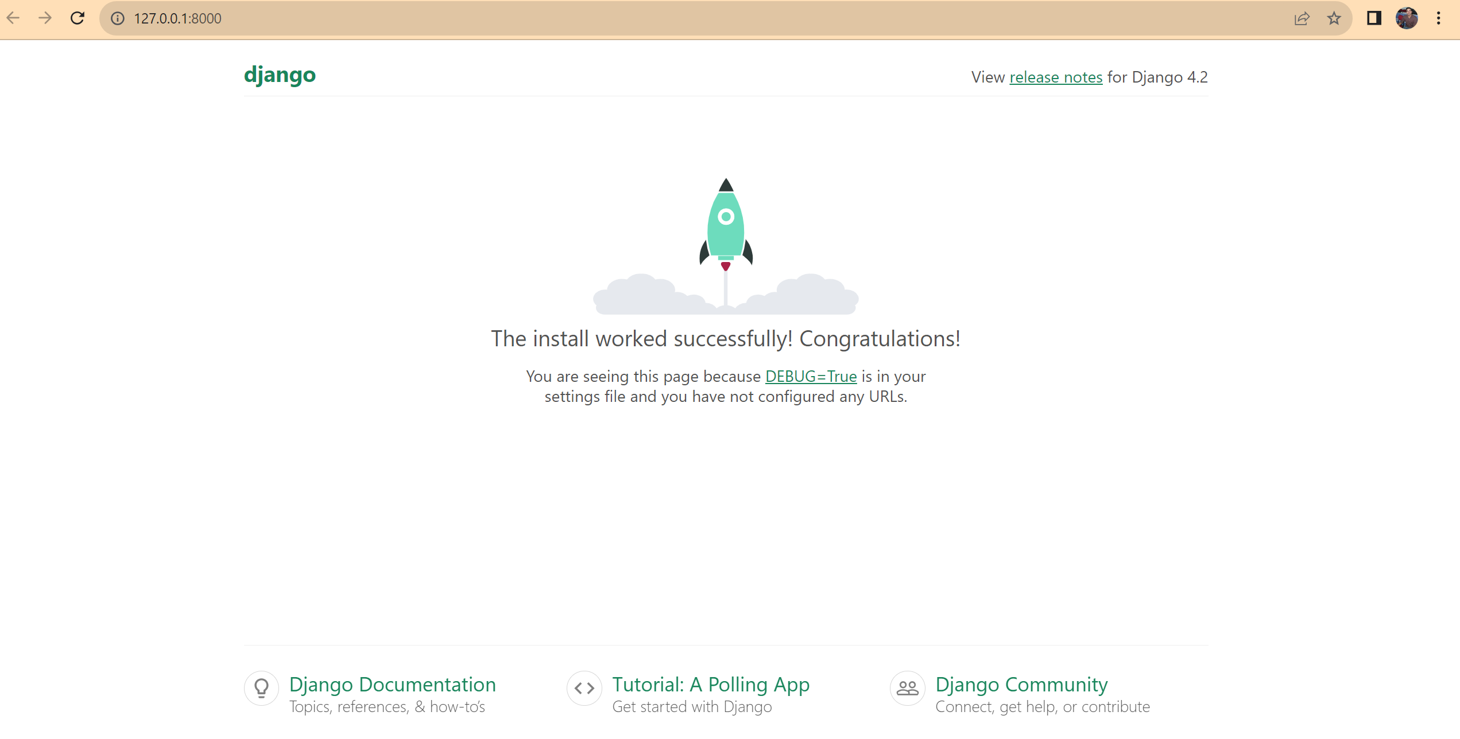

Phase 2: Creating the python application as per the Django architecture by opening with any IDE (Ex. Visual Studio Code Editor) and Integrate Static webpages with the created python application in its architecture.
- Open visual studio code editor and open the project folder in which manage.py exists
- Create an urls.py file in application created (Ex: kitsapp) and write the necessary code in it
from django.urls import path
from . import views
urlpatterns=[
path('',views.index,name='index'),
]
- Create a function “ index “ in views.py file in application(Ex: kitsapp) as below:
from django.shortcuts import render
from django.http import HttpRequest,HttpResponse

def index(request):
return HttpResponse('<h1>welcome to my world</h1>')

- Configure the application (Ex: kitsapp) urls file into Project (Kitsproject) urls.py file as below
from django.contrib import admin
from django.urls import path,include

urlpatterns = [
path('admin/', admin.site.urls),
path('',include('kitsapp.urls'))
]
- Steps to integrate the static webpages with necessary resources like images css files etc…
- Create a “templates” folder under root folder and dump all the html files in it
- Create a “static” folder under root folder and dump all the css and images in it.
- Configure the templates folder in settings.py file in project(Ex: Kitsproject) folder
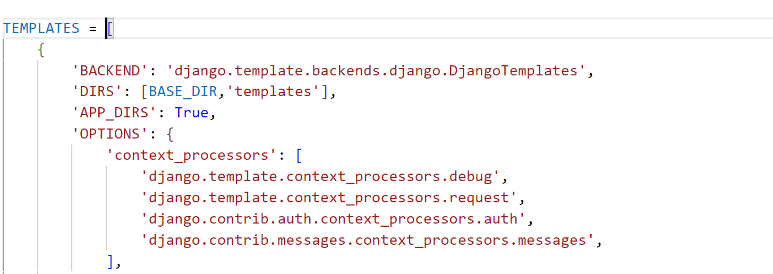
- Configure the static folder in settings.py file in project(Ex: Kitsproject)
import os
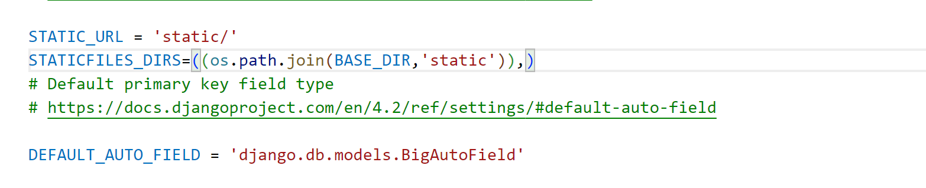

Phase 3: Integrating the database with the above created python web application

